Truncated Antiprism

Definition
# Source: AI Source: Provided by: [Data Path: Persons Table -> ID Column: 1, Name_En Column: Motasem Essam] -> From: [ChatGPT] on [7/25/2026]
A Truncated Antiprism is a solid derived from an antiprism by cutting off one or more portions using planes.
An antiprism has two parallel polygonal bases, with one base rotated relative to the other, and a band of alternating triangular lateral faces connecting them.
Truncation modifies this original structure by removing portions of the solid and creating new polygonal faces. The resulting shape depends on the cutting method.
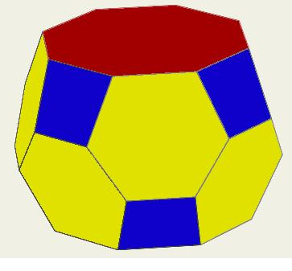

Geometric Structure
# Source: AI Source: Provided by: [Data Path: Persons Table -> ID Column: 1, Name_En Column: Motasem Essam] -> From: [ChatGPT] on [7/25/2026]
An antiprism consists of:
- 2 Polygonal Bases: Parallel and congruent, with one base rotated relative to the other.
- Triangular Lateral Faces: Connecting the two bases in an alternating arrangement.
- Vertices: Located around the upper and lower bases.
- Edges: Connecting the base vertices and forming the triangular lateral faces.
Truncation modifies this structure by cutting off vertices or removing portions using planes.
Common truncation arrangements include:
- Vertex Truncation: Cutting off some or all vertices.
- Single Plane Cut: Removing a portion using one cutting plane.
- Parallel Cuts: Using two or more parallel cutting planes.
- Multiple Truncations: Cutting several portions from different locations.

Face Composition
# Source: AI Source: Provided by: [Data Path: Persons Table -> ID Column: 1, Name_En Column: Motasem Essam] -> From: [ChatGPT] on [7/25/2026]
The resulting face composition depends on the truncation method.
For example, when all vertices are truncated, the original faces are modified as follows:
Modified Polygonal Bases
The corners of each original polygonal base are cut off, producing larger-sided polygonal faces.
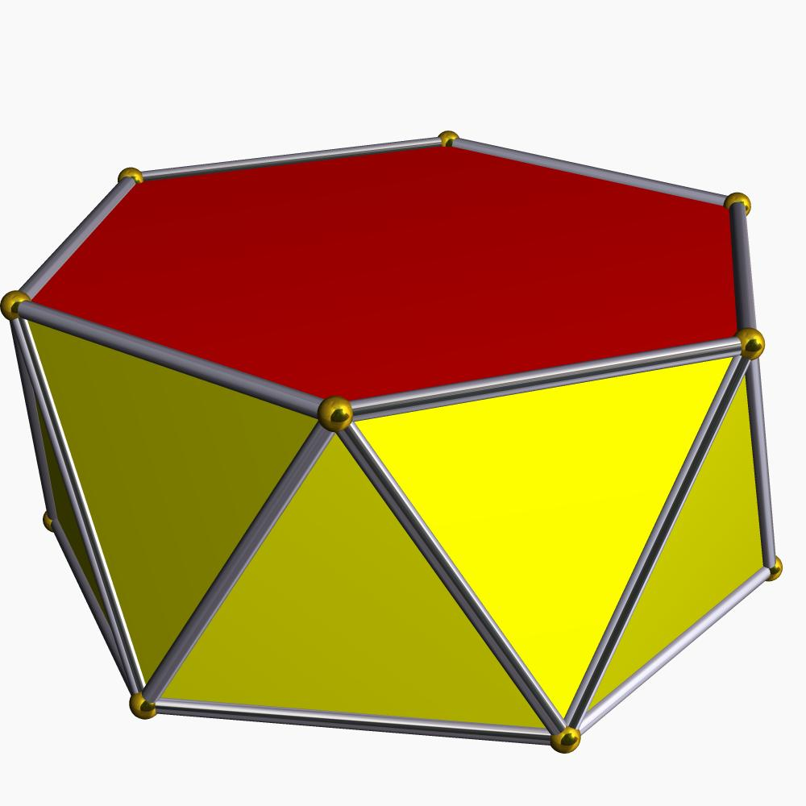
Modified Triangular Faces
The original triangular lateral faces are truncated at their three vertices, producing hexagonal faces.
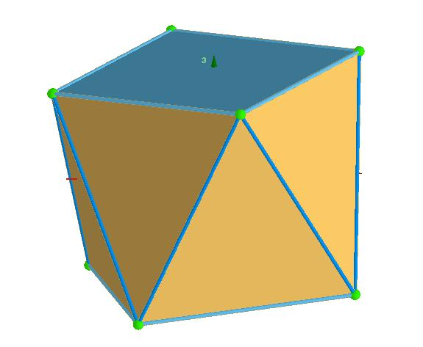
New Quadrilateral Faces
Each truncated vertex produces a new face corresponding to the four edges meeting at that vertex.

Mathematical Properties
# Source: AI Source: Provided by: [Data Path: Persons Table -> ID Column: 1, Name_En Column: Motasem Essam] -> From: [ChatGPT] on [7/25/2026]
For an antiprism with two regular $n$-sided bases:
Original Antiprism
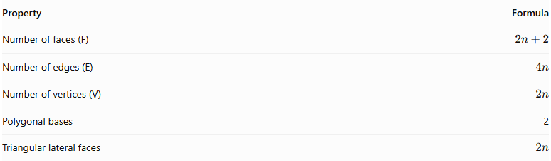
Property | Formula
Number of faces (F) | $$2n+2$$
Number of edges (E) | $$4n$$
Number of vertices (V) | $$2n$$
Polygonal bases | 2
Triangular lateral faces | $$2n$$
After truncating all vertices:
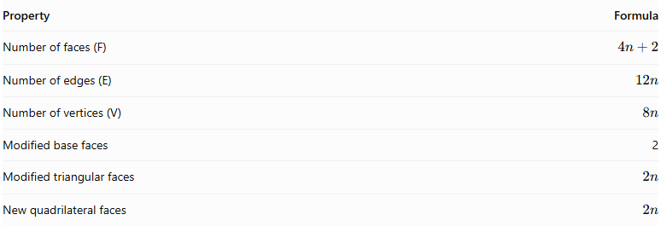
Property | Formula
Number of faces (F) | $$4n+2$$
Number of edges (E) | $$12n$$
Number of vertices (V) | $$8n$$
Modified base faces | 2
Modified triangular faces | $$2n$$
New quadrilateral faces | $$2n$$
These formulas assume that every original vertex is truncated separately and that the cuts do not intersect or remove entire original faces.
Euler's Formula
$$V-E+F=2$$
$$8n-12n+(4n+2)=2$$

Constructing a Truncated Antiprism

Geometric Instruments
# Source: AI Source: Provided by: [Data Path: Persons Table -> ID Column: 1, Name_En Column: Motasem Essam] -> From: [ChatGPT] on [7/25/2026]
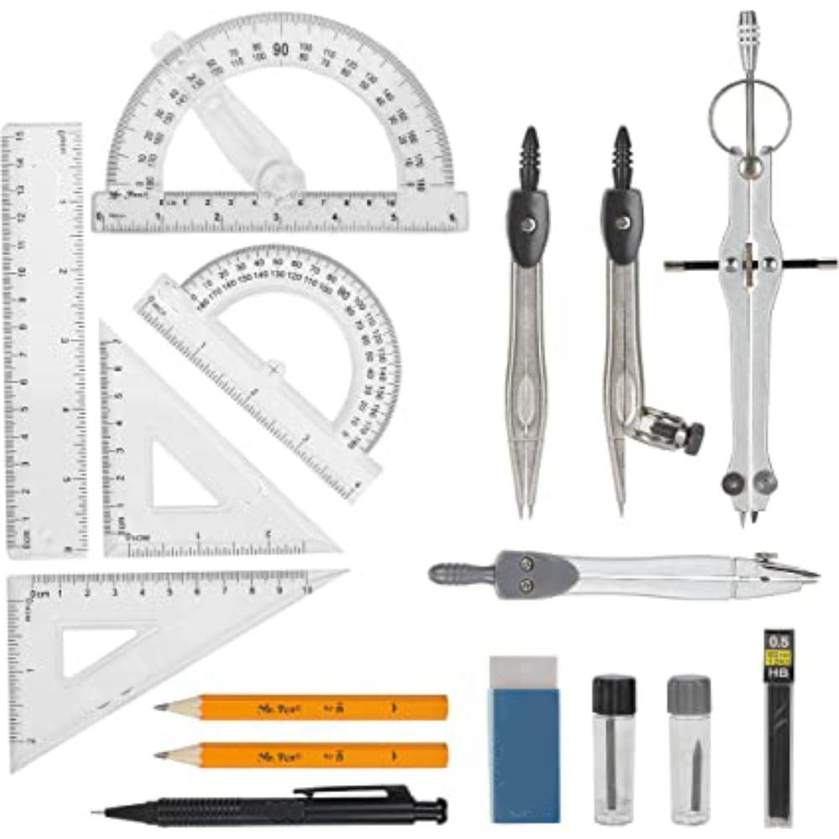
- Ruler / Straightedge: Drawing polygon edges, lateral edges, and section boundaries.
- Compass: Constructing regular polygonal bases and transferring equal lengths.
- Protractor: Measuring the rotation and inclination of the bases and cutting plane.
- Set Squares: Drawing parallel and perpendicular construction lines.
- Pencil: Drawing outlines and construction lines.
- Eraser: Removing unnecessary construction marks after completing the drawing.

Instrument-Based Construction Procedures

Method 1: Construction Using an Oblique Cutting Plane
# Source: AI Source: Provided by: [Data Path: Persons Table -> ID Column: 1, Name_En Column: Motasem Essam] -> From: [ChatGPT] on [7/25/2026]
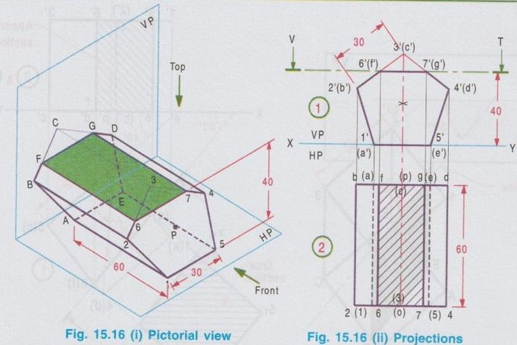
- Draw a regular pentagon $ABCDE$ as the lower base.
- Construct a second congruent pentagon $A_{1}B_{1}C_{1}D_{1}E_{1}$ parallel to the first, rotated relative to it.
- Position the upper base at the required height.
- Connect the two bases with ten alternating triangular lateral faces.
- Identify the ten lateral triangular faces.
- Mark the cutting-plane intersections on the lateral edges so that the plane crosses every triangular face.
- Join the intersection points consecutively to form the new decagonal section.
- Remove the upper portion conceptually, retaining the lower truncated solid.
- Darken the visible edges and use dashed lines for hidden edges.

Method 2: Construction Using Orthographic Views
# Source: AI Source: Provided by: [Data Path: Persons Table -> ID Column: 1, Name_En Column: Motasem Essam] -> From: [ChatGPT] on [7/25/2026]
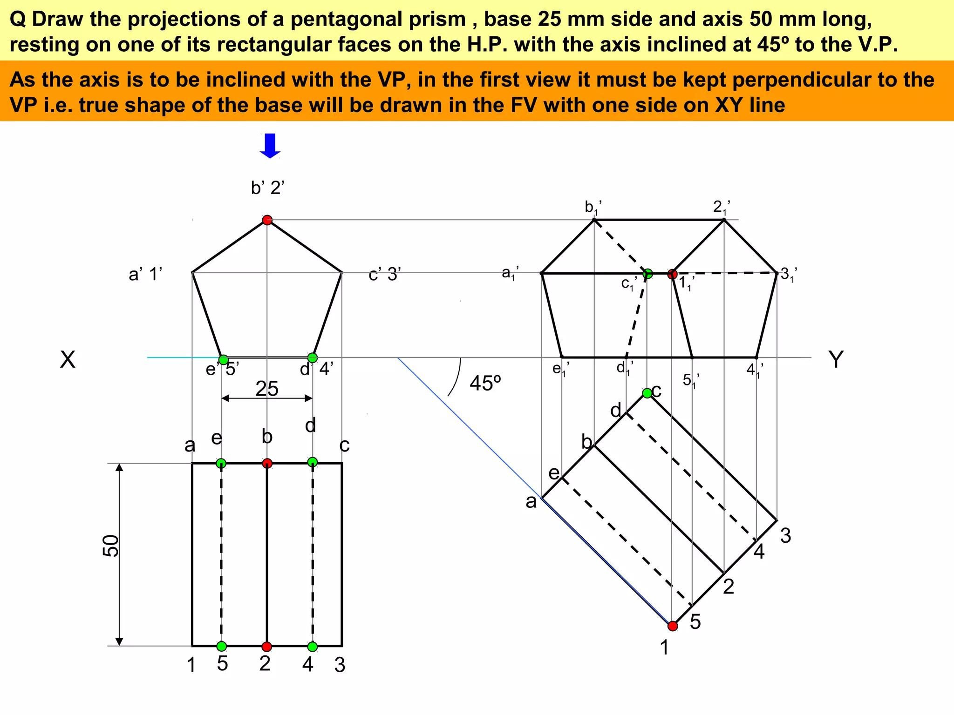
- Draw the lower pentagonal base in the top view.
- Construct the rotated upper pentagonal base.
- Project the vertices into the front and side elevations.
- Connect corresponding vertices to establish the alternating triangular lateral faces.
- Draw the cutting plane in the appropriate elevation.
- Mark its intersections with the lateral edges and triangular faces.
- Project the intersection points into the other views.
- Join the projected points in their correct sequence to construct the new section.
- Complete the isometric view using the orthographic projections.

Method 3: Construction Using Surface Development
# Source: AI Source: Provided by: [Data Path: Persons Table -> ID Column: 1, Name_En Column: Motasem Essam] -> From: [ChatGPT] on [7/25/2026]
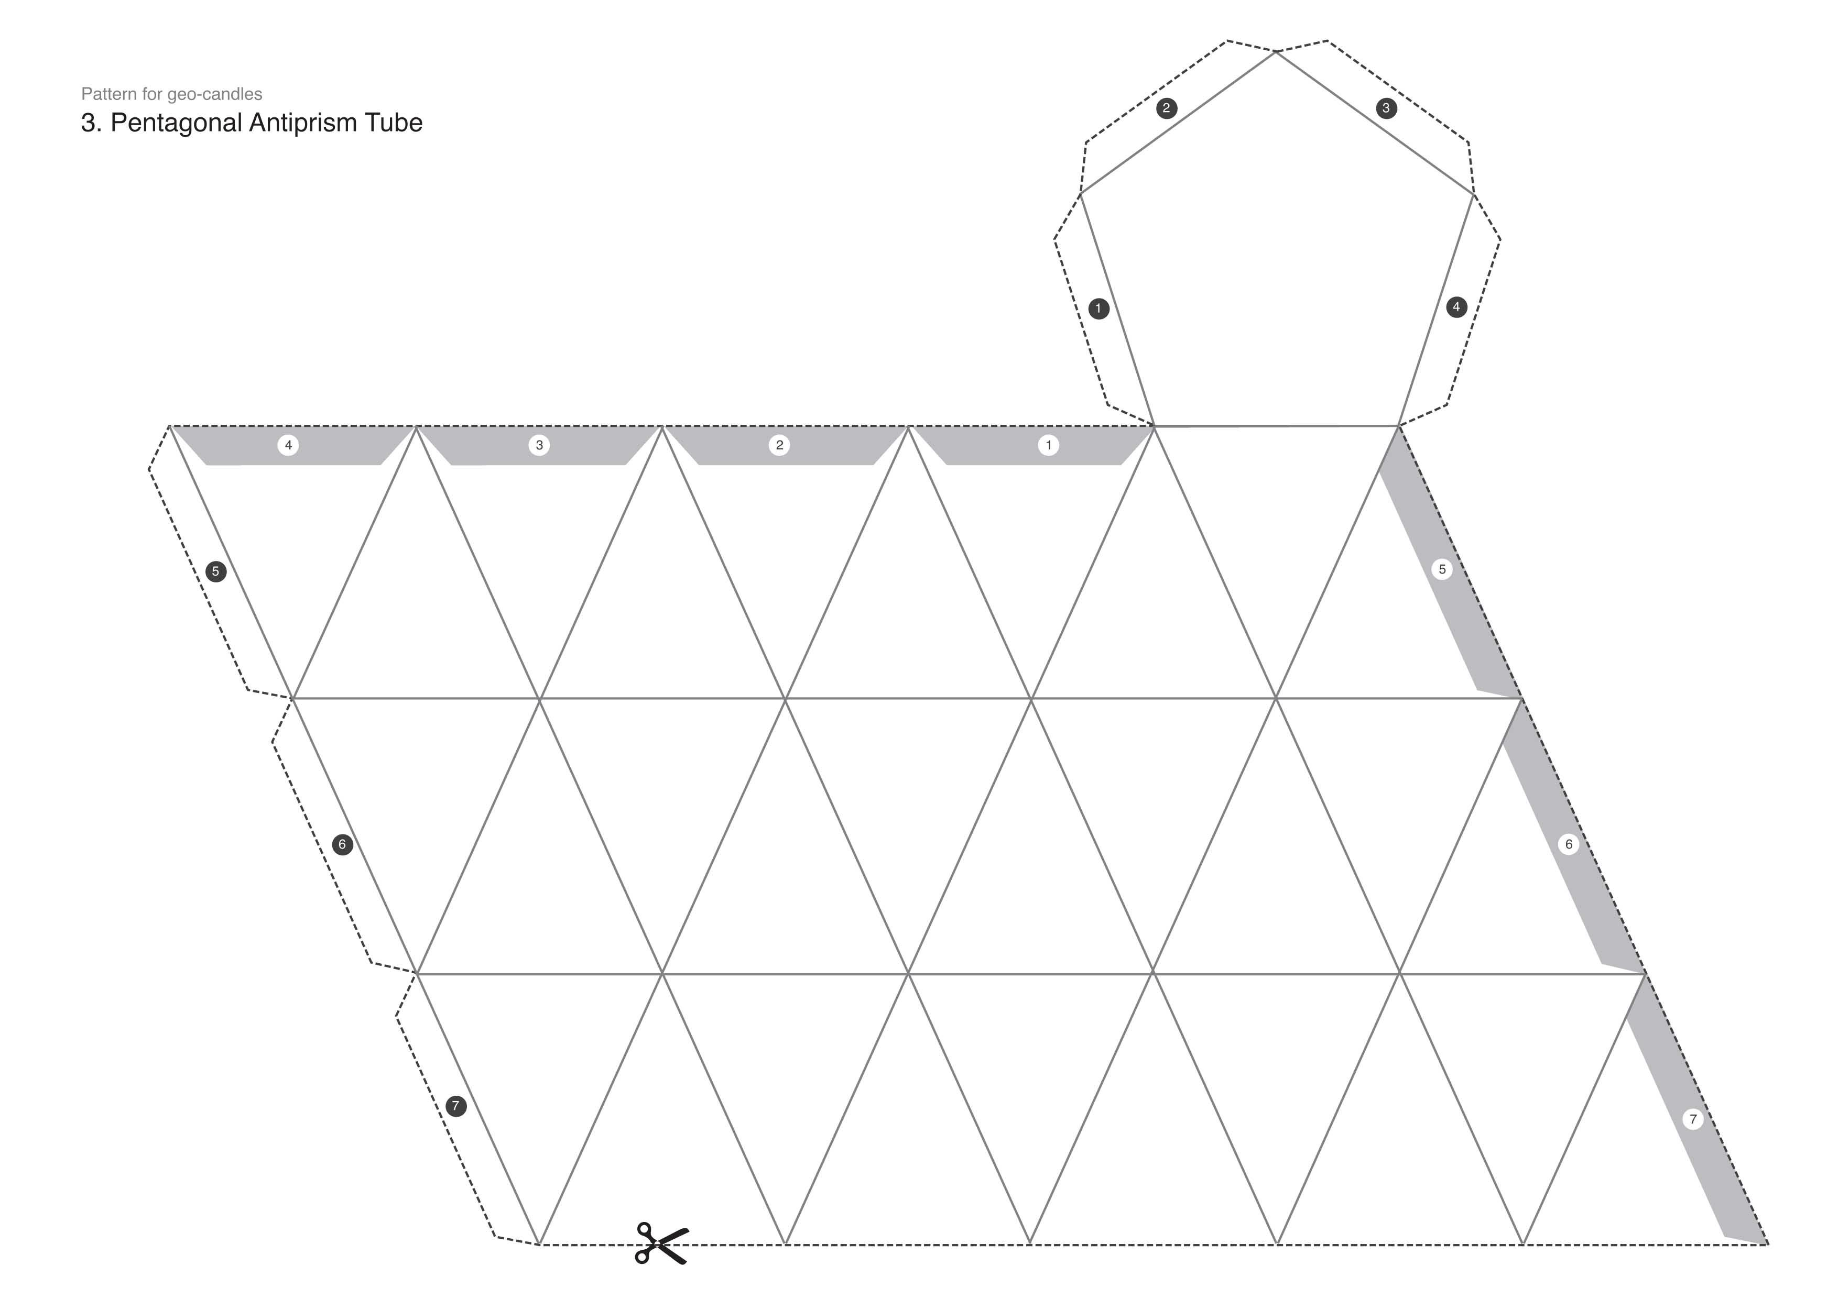
- Draw the development of the antiprism's lateral surface as a connected arrangement of $2n$ triangles.
- Arrange the triangles in their alternating orientations.
- Attach the two pentagonal bases in their appropriate positions in the net.
- Transfer the cutting-plane intersection points from the orthographic views onto the corresponding triangle edges.
- Join the transferred points to form the developed cutting boundary.
- Identify the edges that will be cut and the edges that will be folded.
- Check that adjoining edges have matching lengths.
- Complete the net and distinguish the retained portion from the removed portion.
An antiprism net consists of its two polygonal bases and a band of alternating triangular faces.

Key Points
# Source: AI Source: Provided by: [Data Path: Persons Table -> ID Column: 1, Name_En Column: Motasem Essam] -> From: [ChatGPT] on [7/25/2026]
- It originates from an antiprism.
- It belongs to the family of truncated prisms and antiprisms.
- Its original triangular lateral faces can become hexagonal faces through complete vertex truncation.
- New faces are created at the truncated vertices.
- Its face, edge, and vertex counts depend on the antiprism's base polygon and the truncation method.
- It should not automatically be classified as an Archimedean solid.

Conclusion
# Source: AI Source: Provided by: [Data Path: Persons Table -> ID Column: 1, Name_En Column: Motasem Essam] -> From: [ChatGPT] on [7/25/2026]
The Truncated Antiprism is a modified antiprism formed by cutting off vertices or removing portions using planes. Its resulting structure can contain modified polygonal bases, hexagonal lateral faces, and newly created polygonal faces. Its exact geometry depends on the original antiprism and the truncation method.

